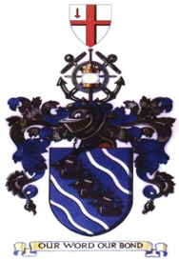
INSTITUTE OF CHARTERED SHIPBROKERS LONDON & SOUTH EAST BRANCH

“OPPORTUNITY TO NETWORK”

NEW VENUE - REVOLUTION BAR

The Branch invites you to come along for a great social night to this superb venue and meet members of the Institute, students and committee to learn more about the Institute, Professional Qualifications and opportunities within the Maritime Industry.

THURSDAY 30TH MAY 2019
FROM 1800 HRS
“REVOLUTION BAR”
140-144 LEADENHALL STREET
LONDON EC3V 4QT

First Drink (Beers/Wine) will be provided.
(until tab expires)
NEAREST UNDERGROUND LIVERPOOL ST

RSVP Mike Harrison (for catering purposes)
Email: activeshipping@gmx.com Tel: +44 (0) 7785 372217

COME ALONG AND SUPPORT THE BRANCH

